PRIYANKA CHAKRABORTY
Department of Mass Communication & Journalism
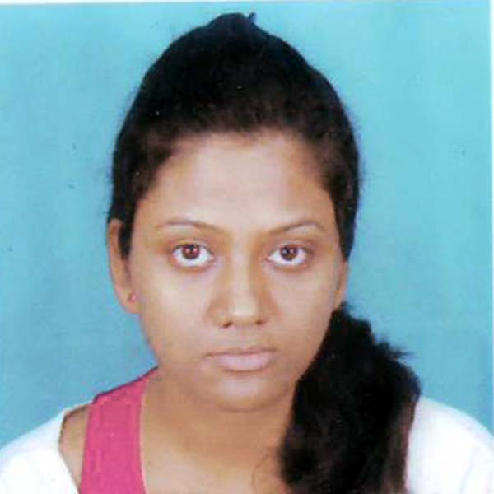
Tezpur University (A Central University), Tezpur
E-mail: ploves8@gmail.com
Mobile no.: +91-8403868703

Address: Refinery Settlement Area. Plot no: 18
P.O.Digboi, Dist: Tinsukia.
PIN-786171, India.

Academic qualifications

- Pursing Master of Arts in Mass Communication & Journalism
Department of Mass Communication & Journalism
Tezpur University, Tezpur
CPI: 9.6/10, 2016

- B.S.C in MCAJ
Massco Media, Noida
Punjab Technical University
CPI: 9.4/10, 2014

- High School, CBSE Board
Percentage: 72%, 2010

- H.L.S.C, ICSE Board
Percentage: 60%, 2008

Achievements

- Participated in the Anuvad the Translation festival and won the first prize for the movie making competition 2016.

- Worked with CNNIBN for India’s Positive Awards Function 2012.
Subjects of Interest
- Media Writing, Visual Communication, Photography, Corporate Communications, Public Relations, Advertising.

Academic Projects
M.A (Dissertation)
Title: Indian Televison Family Advertisement: Youths Perspective.

Films:
The Bindi Project
The Transgression~Saga or Ease
Insecure (psm)

Computer Skills
- Knowledge of working on MS-office.
- Video editing.

Workshops & Internships
- Attended a workshop in Visual Communication the Anuvad Translation festival 2016
- Internship program in (Coal India Limited) North Eastern Coal, Margherita in 2015.
- An internship at Indian Oil Corporation Limited, Assam (Corporate Communications) 2013.
- Internship program in Assam Tribune in 2012.
- Participated in the Two Day Workshop on Heritage Conservation Awareness, Indira Gandhi National Centre for the Art (IGNCA), New Delhi, at Tezpur.

Extracurricular Activities & Interests
- Photography
- Making Documentary Films and Short Films
- RJ’ng
- Content writing
- Dancing, Singing
- Playing Badminton

Personal Details
Date of birth: 12th Aug 1991
Gender: Female
Languages known: English, Bengali, Hindi, Assamse.
Father’s name: Mr. Deepak Chakraborty.
Mother’s name : Mrs. Sunanda Chakraborty.
Permanent Address: Plot Number: - 18, R.S.Area, Digboi, Dist: Tinsukia, Assam, Pin: 786171

Declaration
I hereby declare that all the information given above is true and to the best of my knowledge.

Date: 11-06-2016 (PRIYANKA CHAKRABORTY)

